**Intermediate to Advanced Implant Surgery Techniques**

Speaker: Dr. Shuaib Malik DDS

Host: American College of Maxillofacial Implantology

Sponsor: Nobel Biocare

Date: Friday, September 20th, 2019

**Course overview**

This program is meant as an introductory course about the placement of single dental implants. We will cover:

* Learn the anatomic landmarks related to the [sinus](https://store.nobelbiocare.com/us/en/courses/course-203540) bone augmentation procedure.
* Learn the step-by-step technique for sinus bone grafting procedure.
* Atrophic Maxillary implant placement
* Learn how to use the CT technology for preoperative diagnosis of the sinus anatomy and pathology.
* Learn the most common causes of the intra-surgical and post-surgical complications in sinus bone grafting procedure.
* Recognize the advantages for bone block graft vs. the use of particulate bone grafts for large defects.
* All-on-4 treatment protocol
* Understand prosthetic and surgical protocol in treatment of the edentulous maxilla.
* Recognize surgical protocols for the Brånemark System® Zygoma implants
* View surgical opportunity of the zygoma concept and immediate loading.
* Fundamentals of diagnosis and treatment planning for full arch implant cases



**About the speaker**

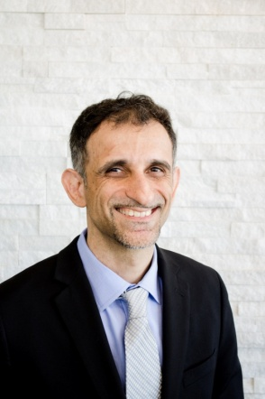**Dr. Malik** obtained his Bachelors of Science with an emphasis in Bio-Physics and Molecular Biology in 1999. Dr. Malik then attended New York University College of Dentistry where he received his degree in 2003.  After dental school Dr. Malik attended the University of Medicine and Dentistry in New Jersey where he completed his residency in Oral and Maxillofacial surgery.

With his extensive training and clinical experience, Dr. Malik has become a leading provider in the placement of zygomatic implants. onlay and symphyseal/ramus and iliac crest hip bone grafts for patients who have upper (maxillary) and lower (mandibular) deficiencies. Dr. Malik has been priviliged to lecture on implant and reconstructive surgeries around the world.

Dr. Malik is the President of Maxillofacial Institute of Implantology and Vice President of The American College of Maxillofacial Implantology.

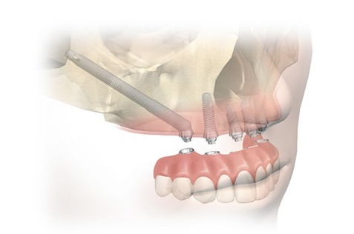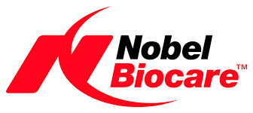

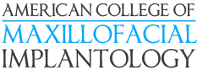

**Course information**

**Intermediate to Advanced Implant Surgery Techniques**

**September 20th 2019**

**Speaker: Dr. Shuaib Malik**

**Location:**

Palos Primary Care Center

15300 West Ave

Orland Park IL 60462

**Times:**

Registration: 8:30 a.m. – 9:00 a.m.

Presentation: 9:00 p.m. –12:00p.m.

Lunch 12:00 pm – 1:00 pm.

Presentation 1:00 p.m. – 4:00 pm

**Fees:**

Complimentary for ACMI members

$95 -non members

ACMl - $75 annual membership for Doctors

CEUs-6 credit hours

**Attendees will receive:**

**Breakfast, lunch, and refreshments**

Course material

Registration

Complete form and email to [amcimplant@gmail.com](mailto:amcimplant@gmail.com) or fax to:

Fax 888.334.0111

Attention: Brian Brewer

For more information, email:

Omfs.brian@gmail.com

General concepts on this topic will be taught utilizing Nobel Biocare products and solutions. Opinions and statements made during this presentation are not necessarily those of Nobel Biocare. Information regarding payments made and expenses covered related to any educational event may be subject to public disclosure by Nobel Biocare pursuant to the Patient Protection Affordable Caro Act and/or other state or federal regulations. Nobel Biocare. the Nobel Biocare logotype, and all other trademarks are, if nothing else is stated or is evident from the context in a certain case, trademarks of Nobel Biocare.

Dental Board of California #RP2499. Nobel Biocare USA. LLC. is an ADA CERP recognized provider.

ADA CERP is a service of the American Dental Association to assist denial professionals in identifying quality providers of continuing dental education. ADA CERP does not approve or endorse individual courses or instructors, nor does it imply acceptance of credit hours by boards of dentistry.

Nobel Biocare USA, LLC. designates this activity for 6 continuing education credits.

Approved PACE Program Provider. FAGD/MAGD Credit. Approval does not imply acceptance by a state or provincial board of dentistry or AGD endorsement (08/01/2013 to 07/31/2016). Provider ID# 208731.

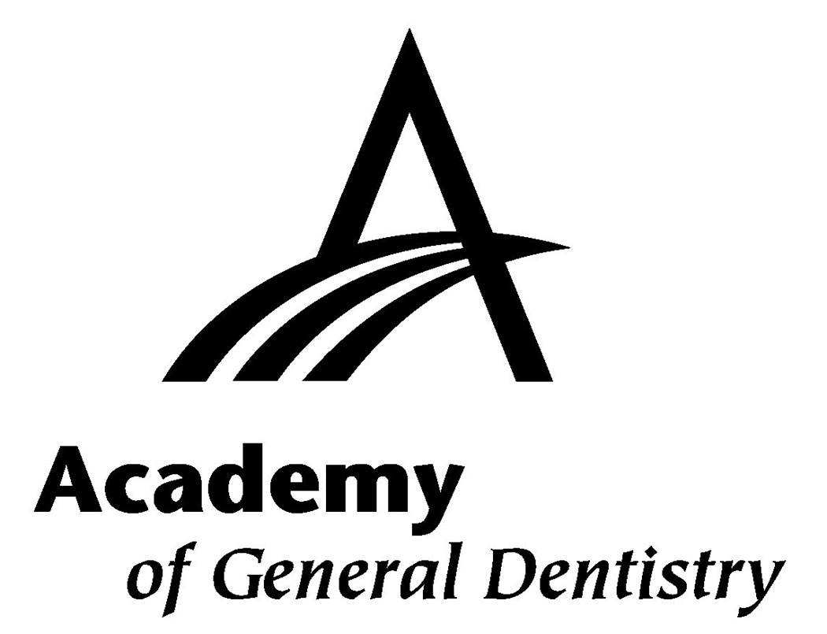

|  |  |  |  |  |  |  |  |  |
| --- | --- | --- | --- | --- | --- | --- | --- | --- |
| Name | |  |  |  | | □ DDS □ DMD □ CDT | | |
| AGD membership no. | | |  |  | | NPI no. | |  |
| Office address | | | | | | | | |
| City | |  |  |  | | State | | Zip |
| Telephone | |  |  | Fax | |  | |  |
| Email State License # | | | | | | | | |
|  |  | |  | |  | |  |  |
| Tuition | □ Already an AMCI member – No Charge  □ $75 Become a ACMI members (auto renewal)  □ $95 - Dentist Non member | | | | | |  |  |

**Please indicate payment type**

□ AMEX □ Visa □ MasterCard □ Discover

Credit card number _______________________________________________________

______-_______/_________

Expiration date CVV

Cardholder Signature_________________________________________________________________