Clinical Approaches for Site Preservation vs. Immediate Implant Placement

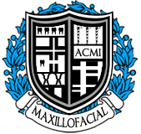

**Speaker: Dr. Matthew Hallas**

**Host: American College of Maxillofacial Implantology**

**Sponsor: Nobel Biocare**

**Date: June 15th 2018**

**About the speaker:**

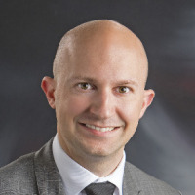

Dr. Matthew Hallas received his Doctor of Dental Medicine from Tufts University School of Dental Medicine in Boston, MA. After graduation, he continued his education at University of Illinois at Chicago – College of Dentistry, completing a 36-month residency in Prosthodontics in which he received extensive training in restorative and surgical therapies. Dr. Hallas is an active member in both the American College of Prosthodontics and the Academy of Osseointegration. He has written several articles and has had several implant-patient therapies published. Dr. Hallas recently moved to Green Bay with his wife and practices full-time at Bay Lakes Center for Complex Dentistry.

Course information

**Location:**

Hilton Garden Inn

1000 Drury Lane

Oak Brook Terrace IL. 60181

**Times:**

Registration: 8:30 a.m. – 9:00 a.m. Presentation: 9:00a.m. – 4:00 p.m.

**Tuition:**

Complimentary-ACMI members

$75 – Dentists/Specialists

$75 - Non-members

$50 - Hygienists

$75 US -ACMl annual membership

CEUs 6 credit hours

**Attendees will receive:**

* **Breakfast, lunch, and refreshments**
* Course material

**Registration**

Register online at [www.acmimplant.com](http://www.acmimplant.com) mail or fax form with payment to:

Fax 888.334.0111

American College of Maxillofacial Implantology

15300 West Ave.

Suite 113

Orland Park, IL 60462

Attention: Brian Brewer

For more information, email:

Omfs.brian@gmail.com

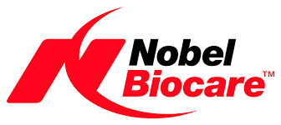

**Course Overview:**

At the conclusion of the course, participants will be able to understand and develop:

Basic restorative and surgical planning skills

Rationale and scientific basis for using the concept of:

Bone Grafting

-Bone biology and formation

-Guided bone and tissue formation

-Principles of socket preservation

-Hands-on Training

Immediate implant therapy

-Techniques in extraction and immediate implant placement

-Restorative techniques for immediate provisionalization

**Objectives:** This program will combine multiple surgical and prosthodontic procedures to help enhance the participant's knowledge in both the restorative and surgical aspects of immediate implant dentistry. This course will focus on deciding when to extract a tooth and complete a socket preservation technique vs. immediate implant techniques following tooth removal with emphasis on evaluation, classification, and treatment guidelines. Parameters to be assessed include gingival biotype, buccal plate status, number of bony walls affected, proper selection and utilization of bone grafting materials, implants stability, and chair side provisional techniques.

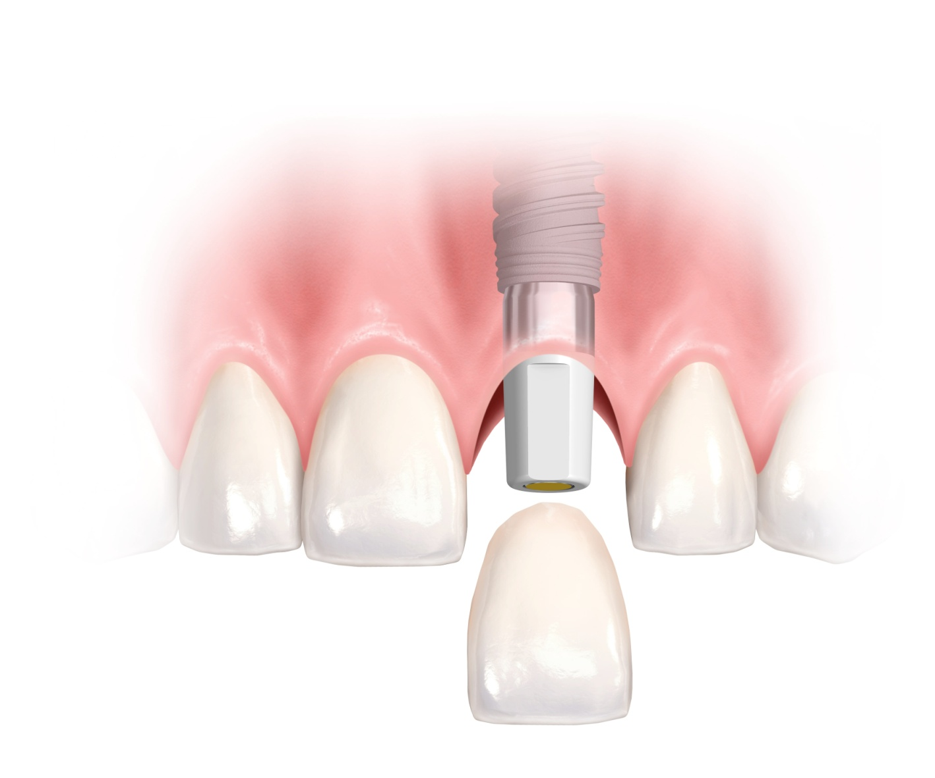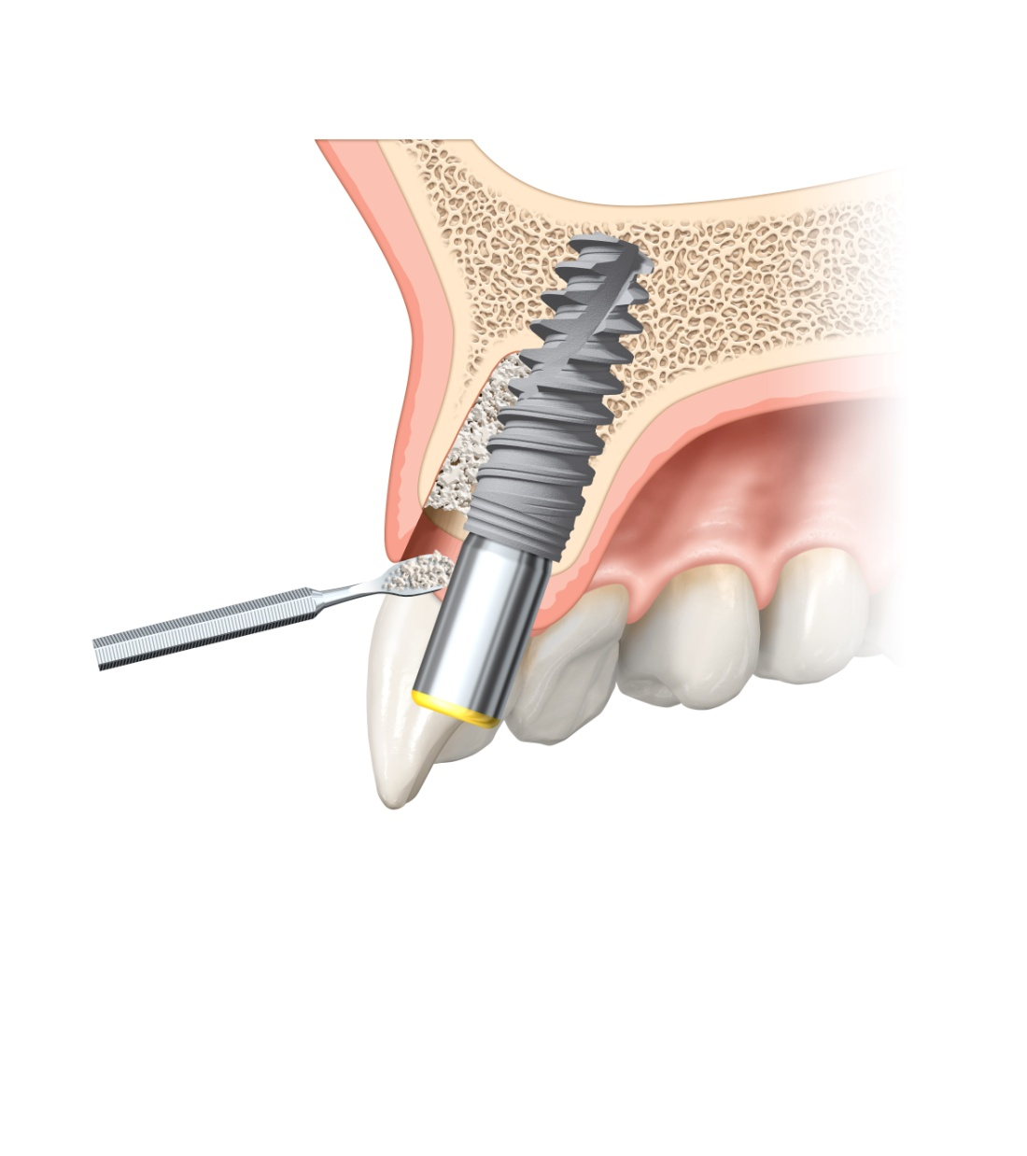

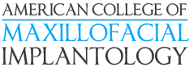

|  |  |  |  |  |  |
| --- | --- | --- | --- | --- | --- |
| Name |  |  |  | DDDS DDMD □ CDT | |
| AGD membership no. | |  |  | NPI no. |  |
| Office address | | | | | |
| City |  |  |  | State | Zip |
| Telephone |  |  | Fax |  |  |
| Email | | | | | |
| Specialty |  |  | State I | cense no. |  |
| Tuition | □ Complimentary-ACMI embers  □ $50US - Hygienists  □ $75 US - Dentists  □ $75 US – Dentist Non member | | |  |  |

***Please print***

D AMEX

*Please indicate payment type*D Visa □ MasterCard

Credit card umber__________________________________________________________/________

Expiration date CVV

Cardholder signature_________________________________________________________________

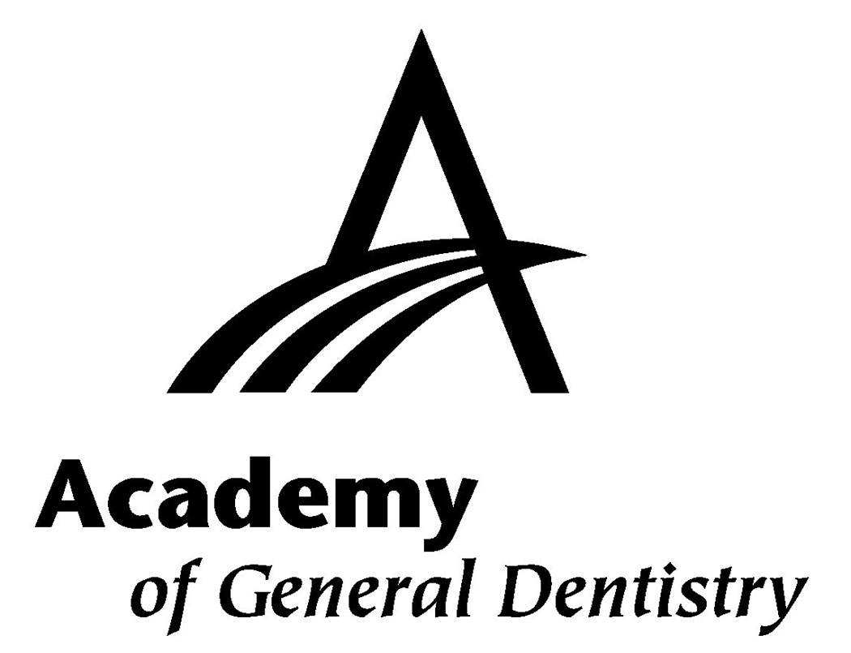

.





General concepts on this topic will be taught utilizing Nobel Biocare products and solutions. Opinions and statements made during this presentation are not necessarily those of Nobel Biocare. Information regarding payments made and expenses covered related to any educational event may be subject to public disclosure by Nobel Biocare pursuant to the Patient Protection Affordable Caro Act and/or other state or federal regulations. Nobel Biocare. the Nobel Biocare logotype, and all other trademarks are, if nothing else is stated or is evident from the context in a certain case, trademarks of Nobel Biocare.

Dental Board of California #RP2499. Nobel Biocare USA. LLC. is an ADA CERP recognized provider.

ADA CERP is a service of the American Dental Association to assist denial professionals in identifying quality providers of continuing dental education. ADA CERP does not approve or endorse individual courses or instructors, nor does it imply acceptance of credit hours by boards of dentistry.

Nobel Biocare USA, LLC. designates this activity for 6 continuing education credits.

Approved PACE Program Provider. FAGD/MAGD Credit. Approval does not imply acceptance by a state or provincial board of dentistry or AGD endorsement (08/01/2013 to 07/31/2016). Provider ID# 208731.



